**DATA ANALYTICS ASSIGNMENT- 4**

Allamudi.Yamini

4th B.Tech (CSE)

VNITSW

20NN1A0562

# One Fixed Lod:

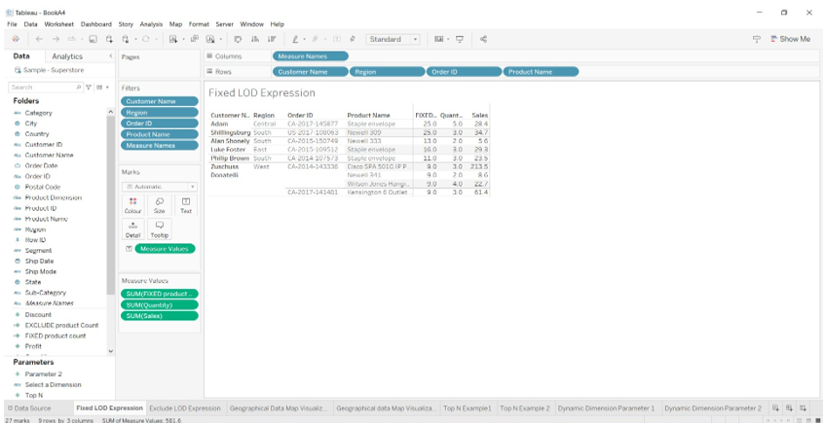

# One Exclude LOD Expression**:**

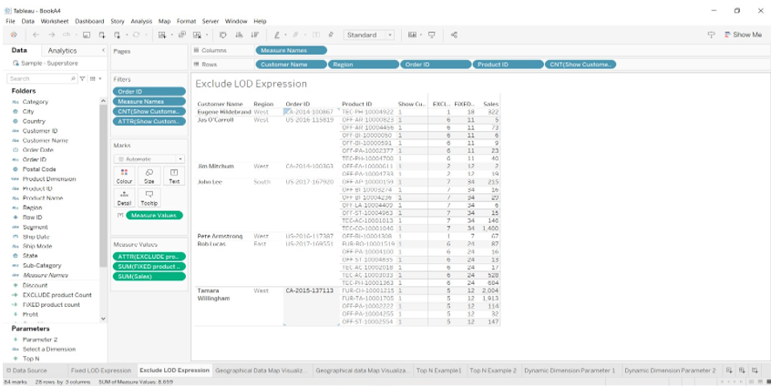

Map Visualization-1:

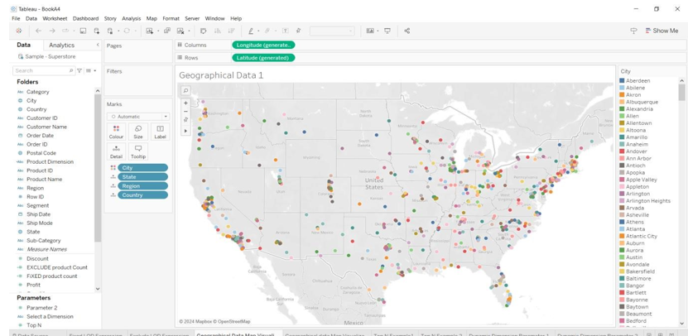

Map visualization -2:

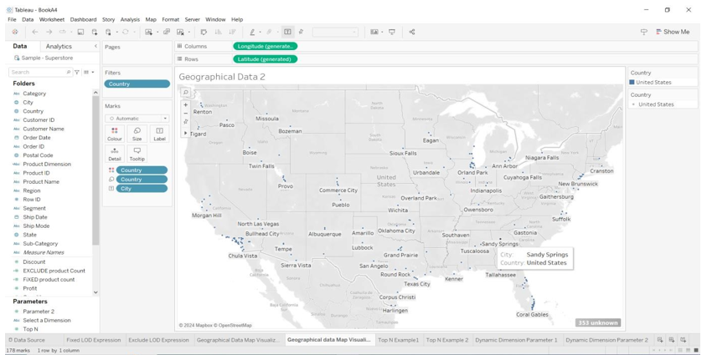

Top N Parameter-1:

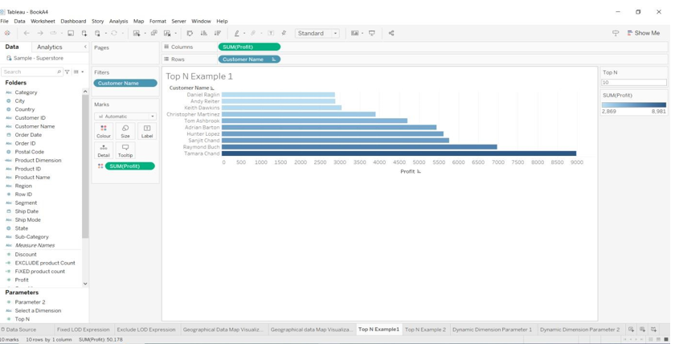

Top N Parameter-2:

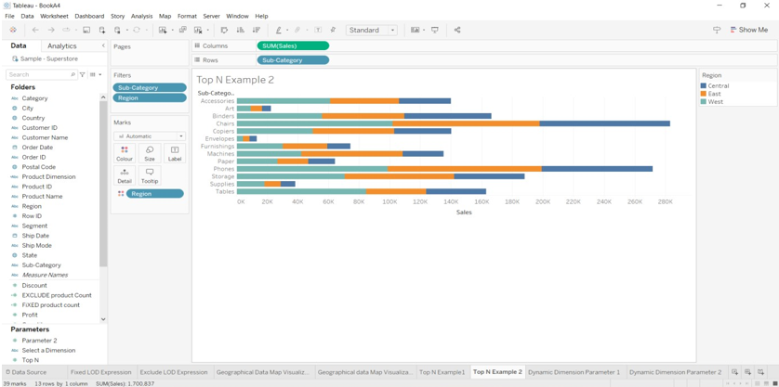

Dynamic Dimension Parameter-1:

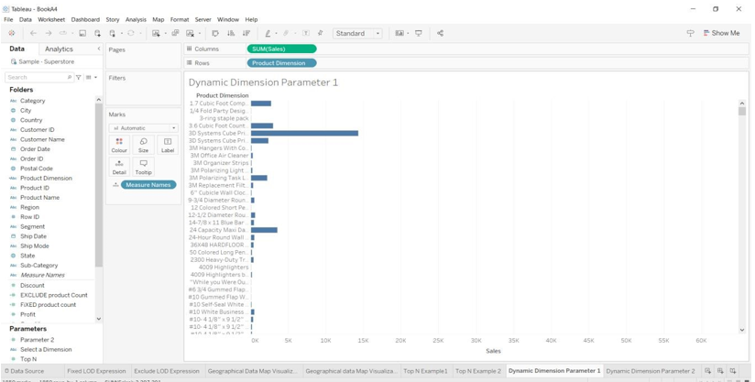

Dynamic Dimension Parameter-2:

